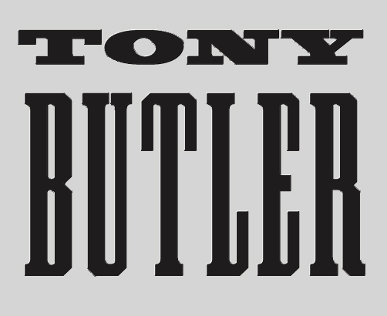

TONY BUTLER - MY TIME BIOGRAPHY

For almost two decades Tony Butler made his mark as bass player and backing vocalist with globally successful rock band Big Country.

Although he officially withdrew from both the group and the mainstream record industry in 2000, Tony remains immersed in music. While concentrating his focus on supporting aspiring young musicians as a teacher, he has continued to write, record and occasionally perform his own songs, as well as collaborating with other artists.

Now directing all his energy into his own creativity, at the age of 60 Tony is about to launch My Time, a new solo album of self-penned songs that reflect his life’s journey, its highs and lows, triumphs and tragedies.

Anthony Earle Peter Butler was born on February 13, 1957 at Hammersmith Hospital in West London. His parents were from the small island of Dominica in the West Indies and had emigrated to England a year earlier.

Living first in Shepherds Bush and then Ealing, Tony’s turning point growing up was witnessing the pop genius of Marc Bolan and T Rex on Top of the Pops. Enchanted by the magic of 1970s rock, his interest was encouraged and nurtured at secondary school in Ealing by an enlightened music teacher named John Williams.

With T Rex, Jimi Hendrix, Yes, Genesis, Bob Marley and The Who as early influences, Tony taught himself to play bass guitar and was soon hired by his vocalist cousin Ben Frampton to play calypso and reggae with London’s West Indian dance bands.

But rock music was Tony’s first love and, when a schoolfriend introduced him to Simon and Paul, younger brothers of the Who's Pete Townshend, his fate was sealed. Tony became a member of the Simon Townshend Band, later called On The Air, playing countless gigs on the pub and college circuit before the group – also featuring Big Country drummer Mark Brzezicki – were signed to WEA Records.

On The Air released two singles and in 1980 toured the UK with Scottish band The Skids, which is when Tony and Mark first encountered Stuart Adamson.

Meanwhile the young bassist’s skills had come to the attention of Pete Townshend who asked Tony to play as a session musician on his solo album Empty Glass.

With the demise of On The Air, and other session requests rolling in, Tony and Mark created a bass and drums duo called Rhythm for Hire (unofficially dubbed “the Sly and Robbie of Soho”), playing and recording with various high-profile artists.

Highlights of Tony’s recording career during this period included sessions with Pete Townshend (All Good Cowboys Have Chinese Eyes, White City), Roger Daltrey (Under A Raging Moon), The Pretenders (Back On The Chain Gang/My City Was Gone), TV appearances withThe Creatures – aka Siouxie Sioux and Budgie, and a video with Nils Lofgren (Flip Ya Flip). He worked with notable record producers including Steve Lillywhite, Mickie Most, Chris Thomas, Ron Nevison and Alan Shacklock.

Then in 1981 Tony and Mark were asked to record some demos with Stuart Adamson – an invitation which marked the start of an incredible journey. They officially joined Big Country in the same week that Tony gracefully declined a request from Chrissie Hynde to join The Pretenders.

Big Country enjoyed phenomenal success in the 1980s and 90s. They released seven studio albums, 15 compilation/live albums, 17 top 30 British singles, a number one single in the Republic of Ireland, a simultaneous single and album in Billboard top ten and two Grammy nominations.

They toured all over Britain, Europe, USA, Canada and Japan, playing concerts halls, arenas and festivals. They were the first band to play to a standing audience in Moscow and also played a show in post-war Kosovo.

They supported Queen at Knebworth, David Bowie on his Glass Spider tour, the Rolling Stones in Europe on both the 1995 Voodoo Lounge tour and the 1998 Bridges to Babylon tour.

After moving to Cornwall with his family, Tony became increasingly focused on making music closer to home. He set up Great West Records in the mid-1990s to help new bands and writers in the West Country and released his first solo album, The Great Unknown.

Tony announced his departure from Big Country in 2000 after the promotion of their last studio album, Driving to Damascus – which he still regards as their best – and the Final Fling farewell tour.

This original line-up played just one more gig – in Malaysia – prior to Stuart Adamson’s tragic and untimely death in December 2001.

In 2005 Tony release a second solo album, Life Goes On, while qualifying as a further education teacher and finding his feet in the world of education.

After briefly joining forces with his Big Country bandmates, drummer Mark and guitarist Bruce Watson, to play a series of live shows in 2007. But Tony felt unable to perform with Stuart no longer centre stage and withdrew from the band once more. Mark and Bruce continue to keep the music of Big Country live with a new line-up and regular tours.

The heady heights of the glory years may be long gone but with such a bounty of musical and personal experience to draw upon, Tony has decided to harness those riches and share his memories and observations in the way he knows best in My Time.

Written by Jacqueline Butler © May 2017

